St Columba’s Parish Church, Knock, Belfast

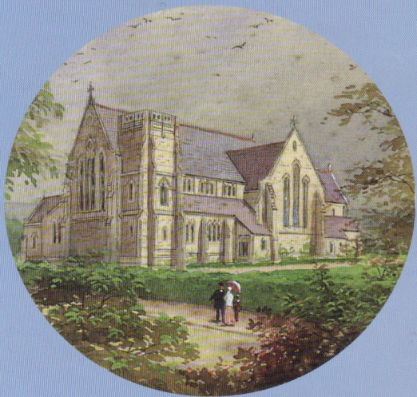

RECITAL

Ioana Petcu-Colan (Leader, Ulster Orchestra)

Tristan Russcher (piano / organ)

Anne Harper (clarinet)

Sungho Jang (piano)

Vocal Items from St Columba’s Cantors

Joe McKee

*Music by Pergolesi, Haydn, Fauré, Stanford & Finzi.*

Saturday 16 November 2024 at 7.30pm

Voluntary Donations (suggest £15) for Church Funds

*Light refreshments will be provided after the concert.*